Whistleblowing Policy





GIL SERVICES LTD

**Whistleblowing Policy**

# Purpose

The purpose of this policy is to provide a framework for employees to report concerns about wrongdoing, illegal activities, or unethical behaviour within our organisation. This policy is designed to encourage and protect employees who speak up about such issues in good faith.

# Scope

This policy applies to all employees of our organisation, including full-time and part-time employees, contractors, and temporary employees.

# Reporting

If an employee has a concern about wrongdoing, illegal activities, or unethical behaviour, they should report it to their immediate supervisor or manager. If the concern is about their supervisor or manager, they should report to the company directors.

If an employee feels uncomfortable reporting the concern to their supervisor or manager, they may report it directly to the company directors.

Employees may report concerns anonymously, but they are encouraged to provide their contact information so that they can be contacted for additional information or to follow up on the report.

# Investigation

All reports of concerns will be promptly investigated. The investigation will be conducted in a manner that protects the confidentiality of the employee who made the report, to the extent possible. The investigation will be conducted by a designated person or team, such as the company directors.

The investigation will be completed as quickly as possible, and the findings will be reported to the company directors, as appropriate. If the investigation confirms that there has been wrongdoing, illegal activities, or unethical behaviour, appropriate action will be taken, which may include disciplinary action or referral to law enforcement.

# Protection Against Retaliation

Our organisation prohibits retaliation and victimisation of employees who report concerns in good faith. Retaliation includes any adverse action taken against an employee, such as termination, demotion, or harassment, because of their reporting concerns.

Employees who believe they have been retaliated against for reporting concerns should report it to the company directors. Any retaliation will be investigated, and appropriate action will be taken.

Page 1 of 2



# Conclusion

Our organisation encourages employees to report concerns about wrongdoing, illegal activities, or unethical behaviour. This policy provides a framework for reporting concerns and ensures that employees who report concerns in good faith are protected against retaliation.

Gabriel Alexandru Mititelu

|  |  |
| --- | --- |
| Name |  |
| Signed |  |
| Date | 10.04.2025 |
| Position | Director and Company Secretary |

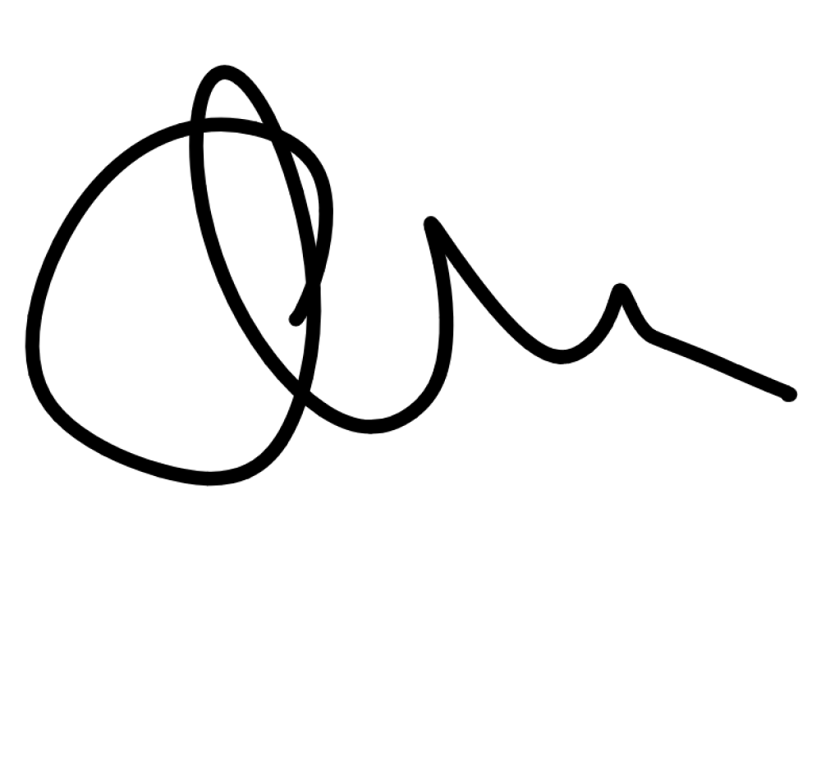

Whistleblowing Policy v1.0

Uncontrolled document when printed Page 2 of 2

Classification: PUBLIC